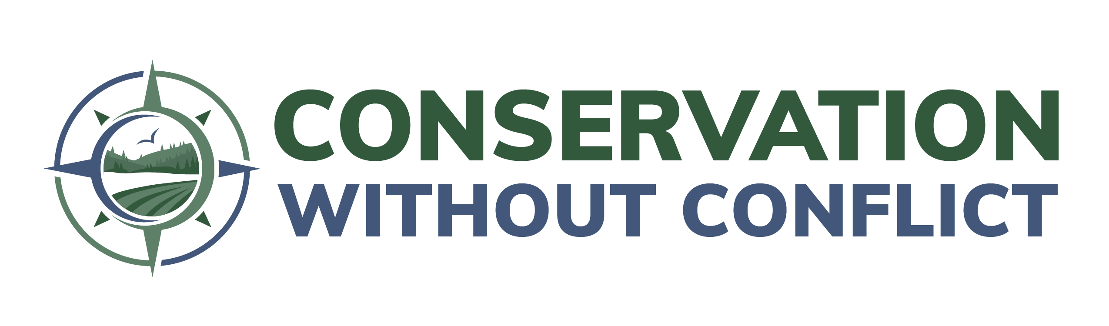

Template for Success Stories

Please share your organization’s success stories that best demonstrate voluntary and collaborative wildlife conservation on working lands. These stories will be used to strengthen the coalition’s communications materials (with appropriate attribution) and will also be analyzed to understand best practices for wildlife conservation on working lands. Please submit as many stories as you have, using one template per project. Save and return completed forms to Lauren Ward at lkoward@gmail.com.
We are grateful for a chance to highlight, share, and learn from your successful projects on the ground.

Project title:

Project contacts and organizations:

Time period:

Geographic region:

Project status (prospective, active, completed?):

List of partners and their roles:

Species targeted and/or habitat type (include ESA status if applicable):

Why was the project started?

What voluntary and collaborative conservation actions were taken?

What challenges or obstacles did you encounter, if any?

Were those challenges and obstacles overcome?
If so, how? If not, why?

What are the outcomes (or anticipated outcomes) of this project?
Please include species, habitat, and human outcomes.

What are the major lessons learned from this project?

Describe the biggest accomplishments of this project?

If you could go back in time, is there anything that you would do differently in this project?

How was the project funded?

Was the project short-term or long-term/sustainable?

